Contents

1.AWS Global Infrastructure 2

11. What is EDGE Location 5

AWS Network and Content Delivery 7

2.VPC (Virtual Private Cloud) 7

VPC peering: 9

Transitive Peering: 10

Creating VPC 10

NAT Instances and Gateway 11

3.Security Groups 11

AWS Sevices

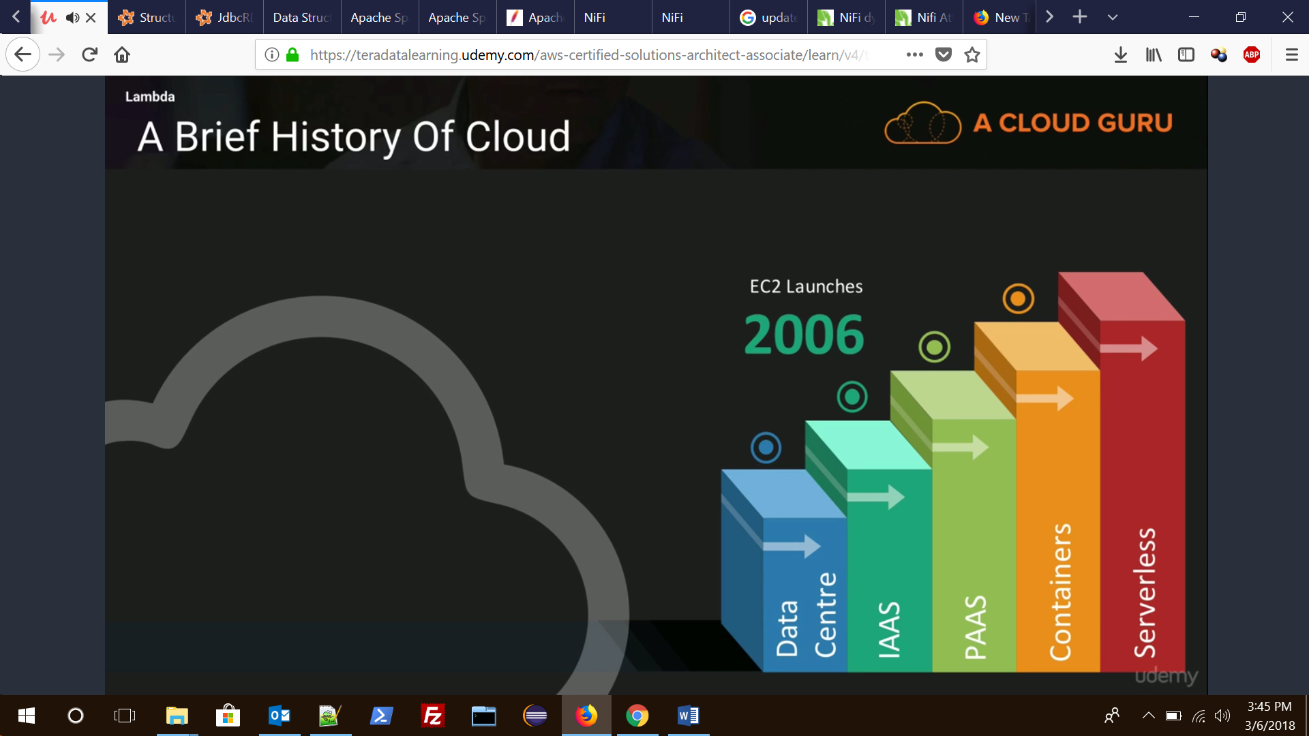

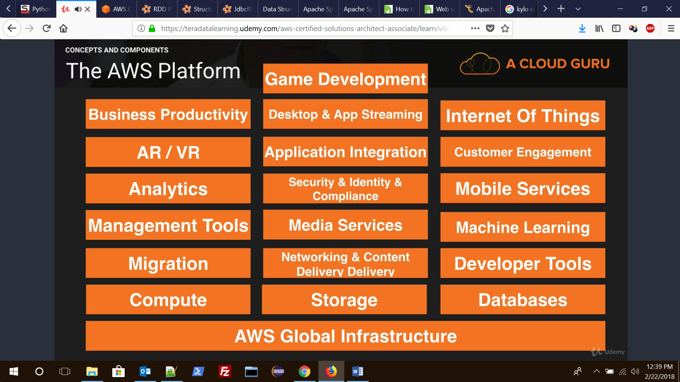

# 1.AWS Global Infrastructure

regions and availability zones in AWS :

Amazon EC2 is hosted in multiple locations world-wide. These locations are composed of regions and Availability Zones. Each region is a separate geographic area. Each region has multiple, isolated locations known as Availability Zones.

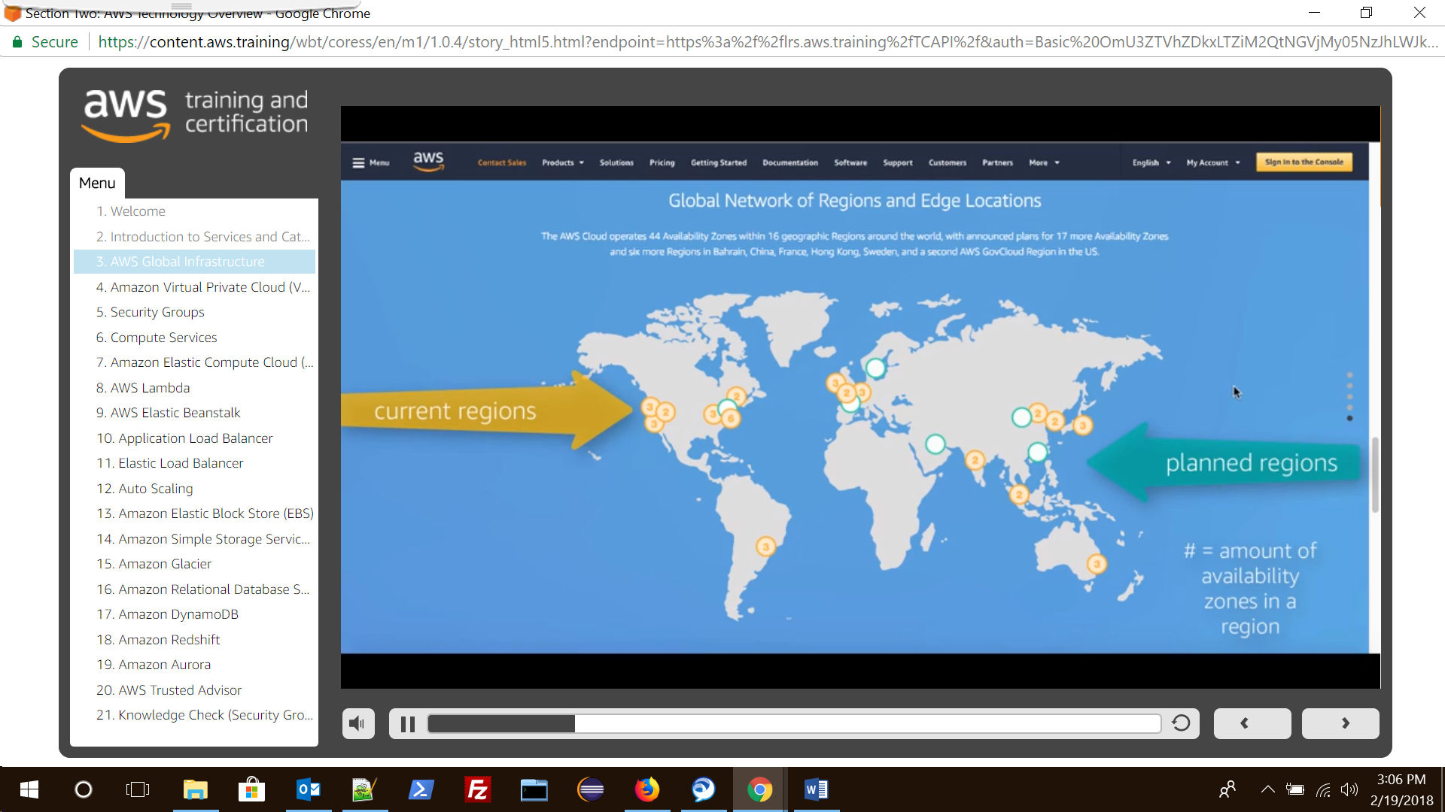

Each **region** is completely **independent**. **Each Availability Zone is isolated, but the Availability Zones (collection of data centre within a regions) in a region are connected through low-latency links**. The following diagram illustrates the relationship between regions and Availability Zones.

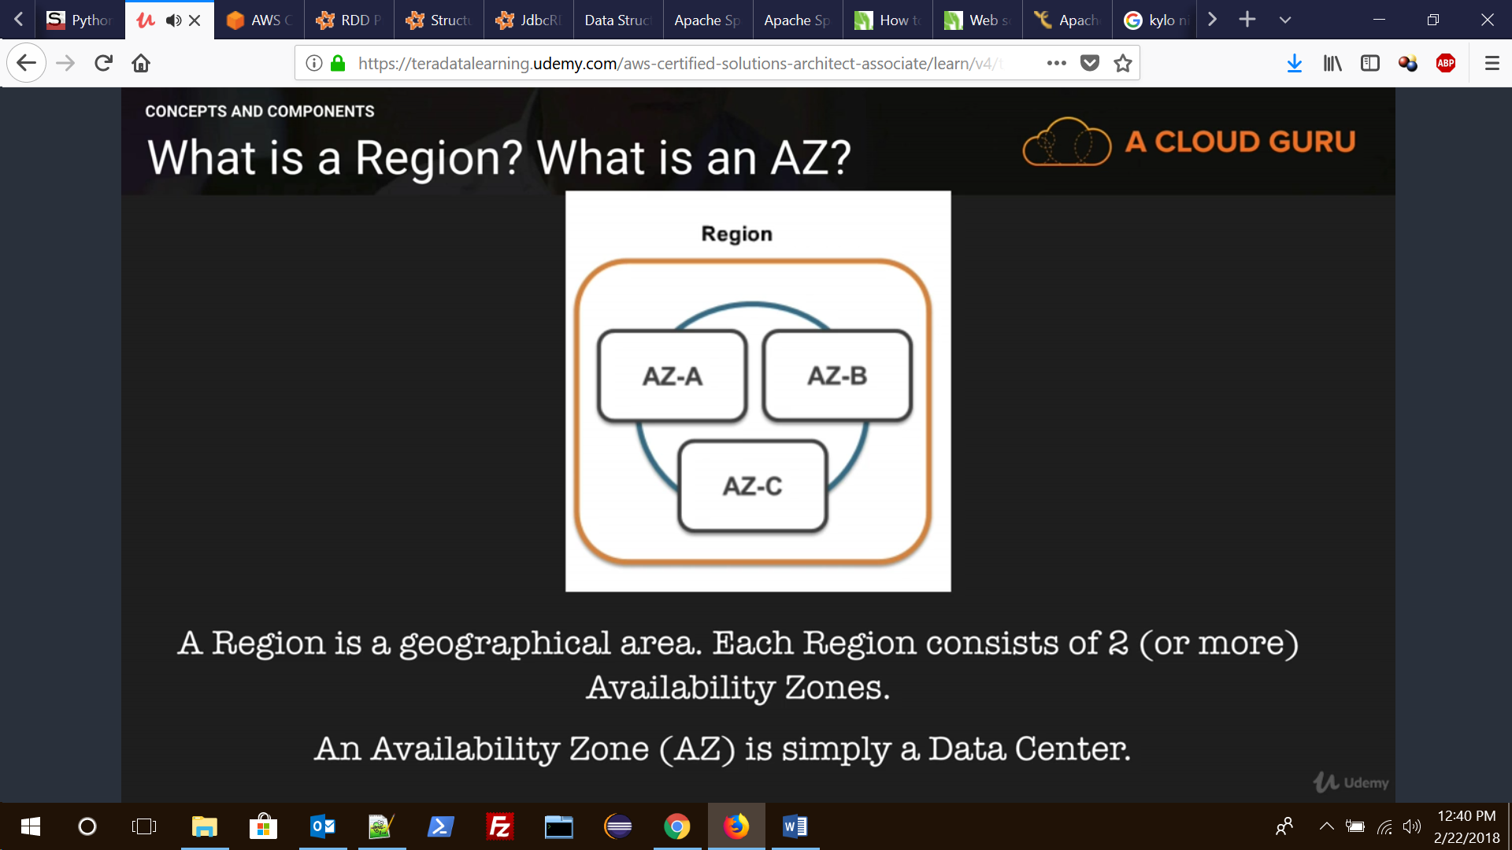

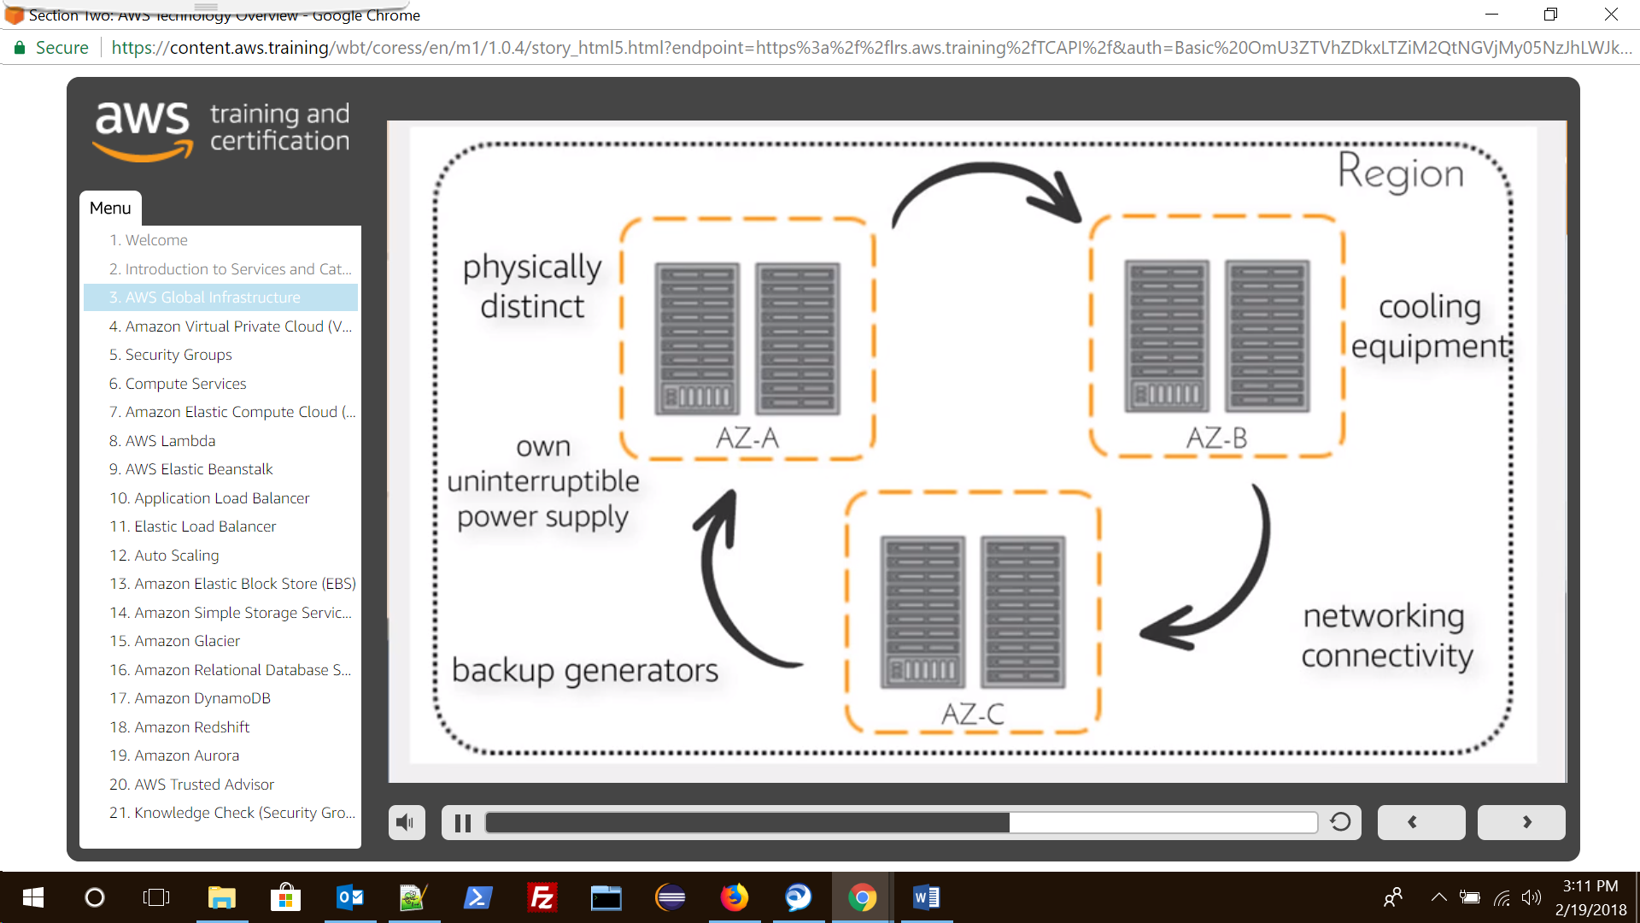

Within each Availability zones lies Data Centres for eg Mumbai is a region, it has three availability zones say at Chennai, Mumbai, and Delhi. Now each of these availability zones will be connected through a very high capacity connections and then within these each availability zones lies Data centres.

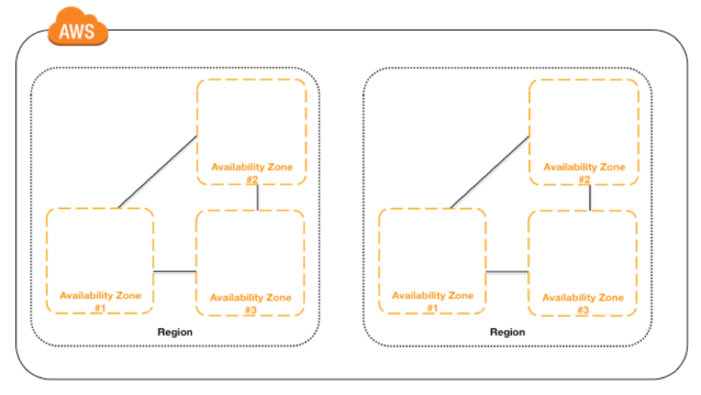

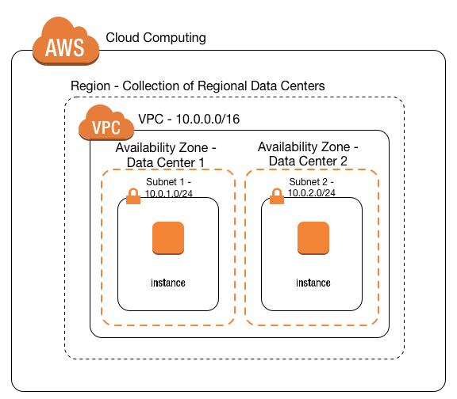

### 11. What is EDGE Location

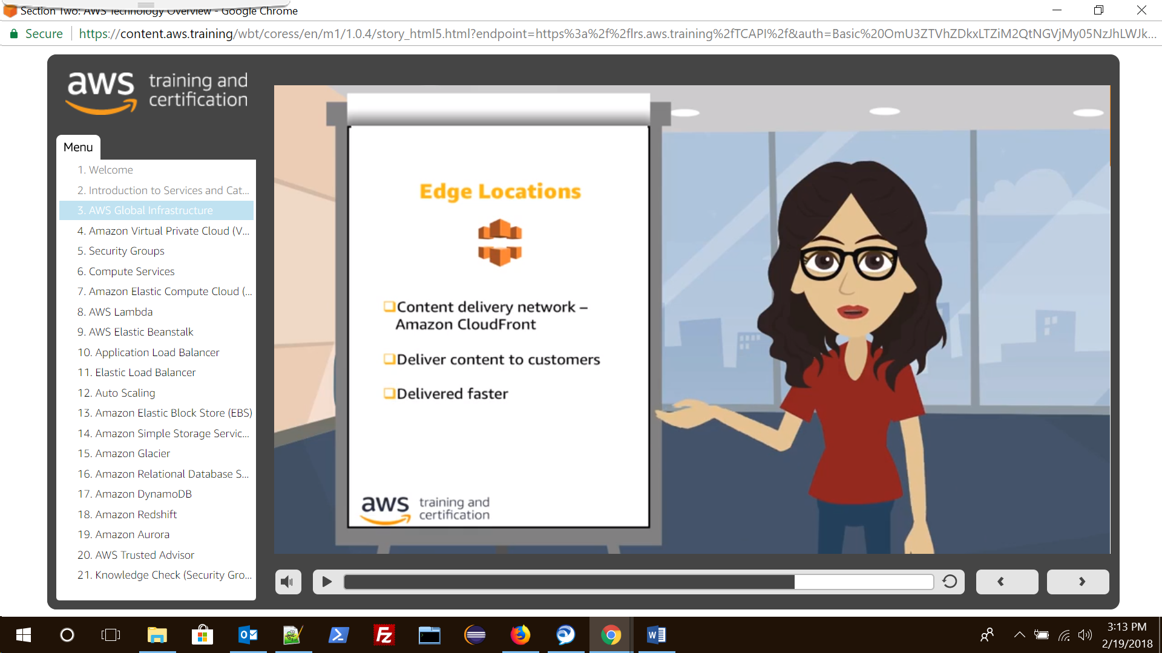

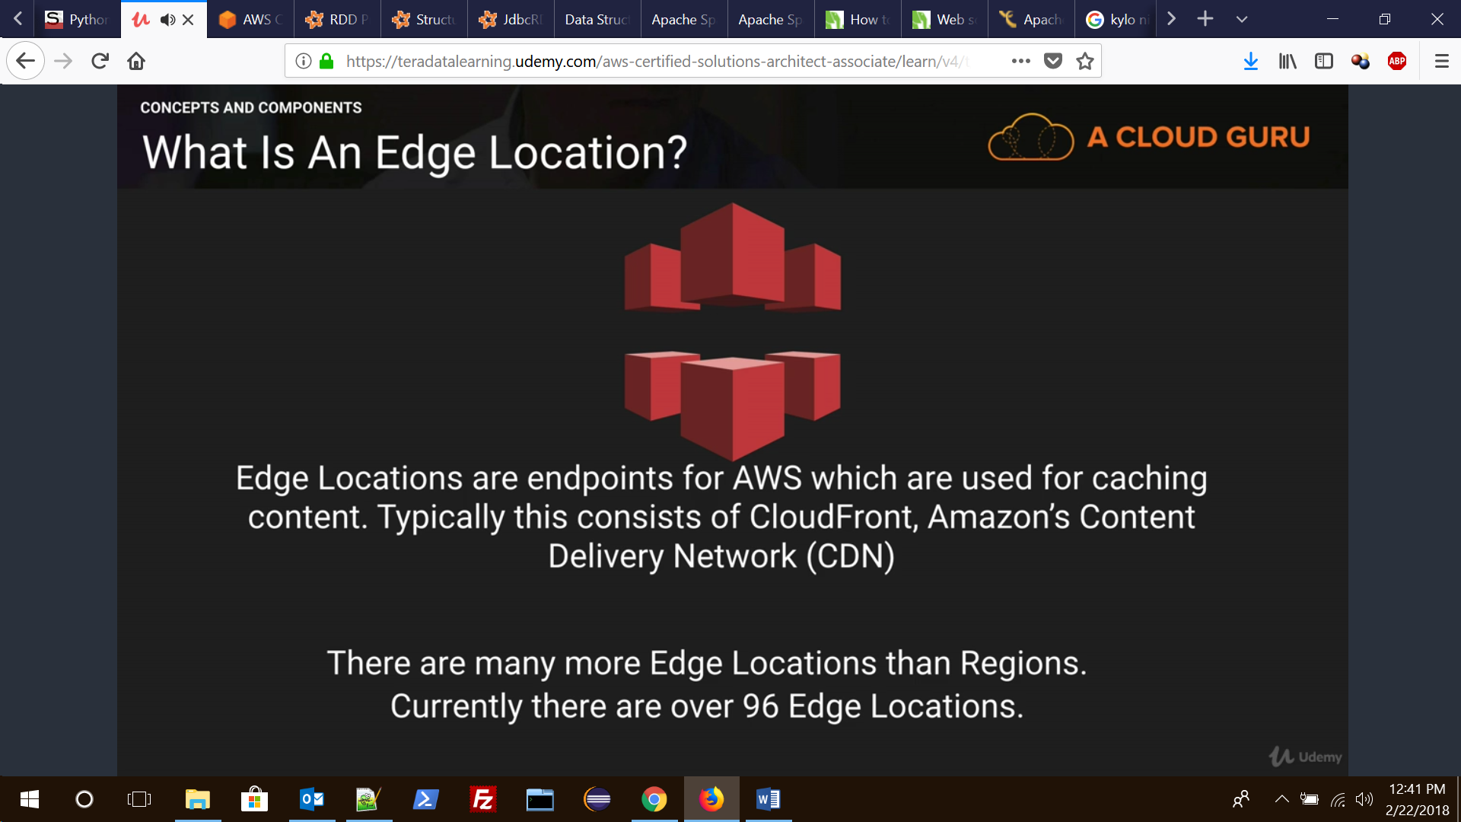

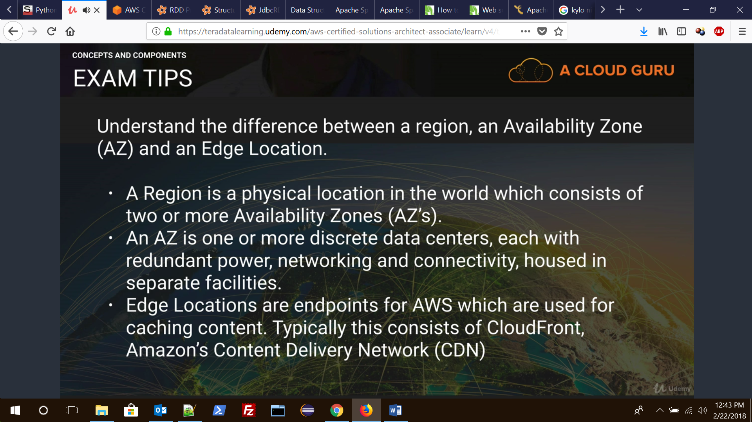

# AWS Network and Content Delivery

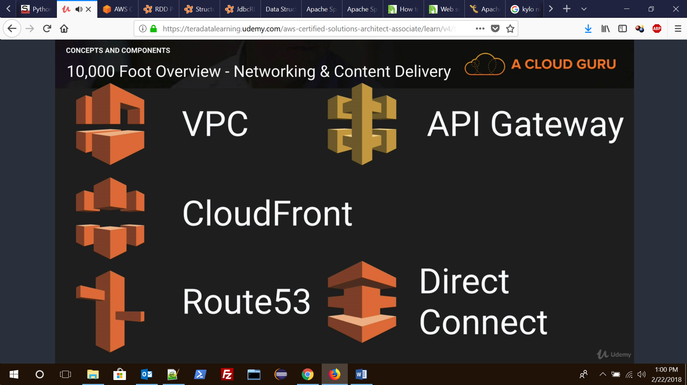

## 2.VPC (Virtual Private Cloud)

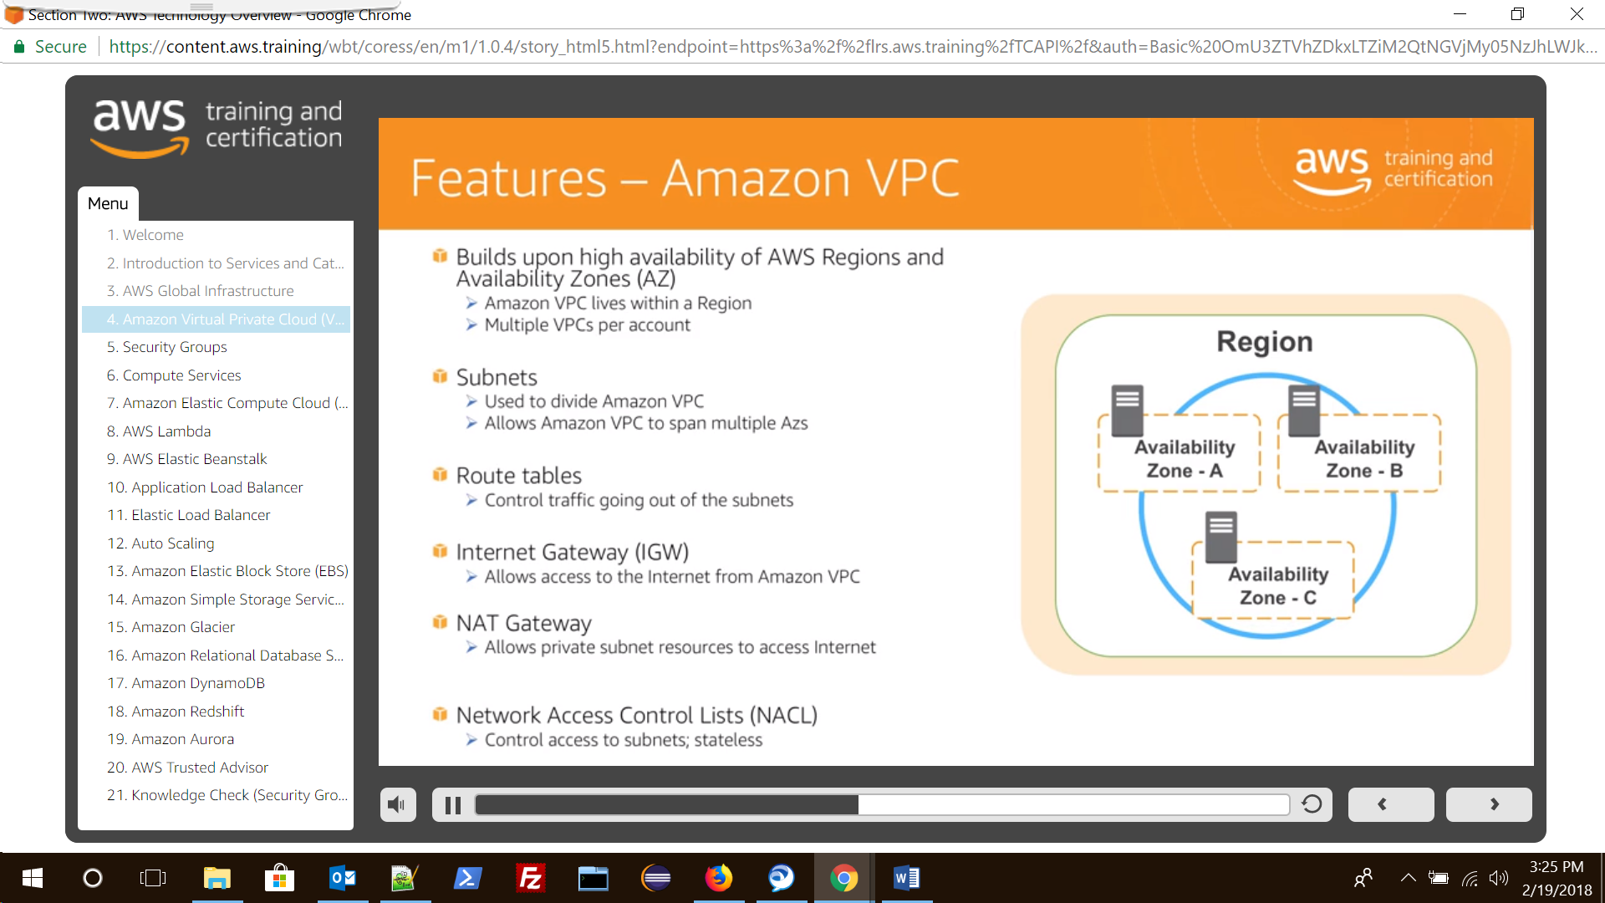

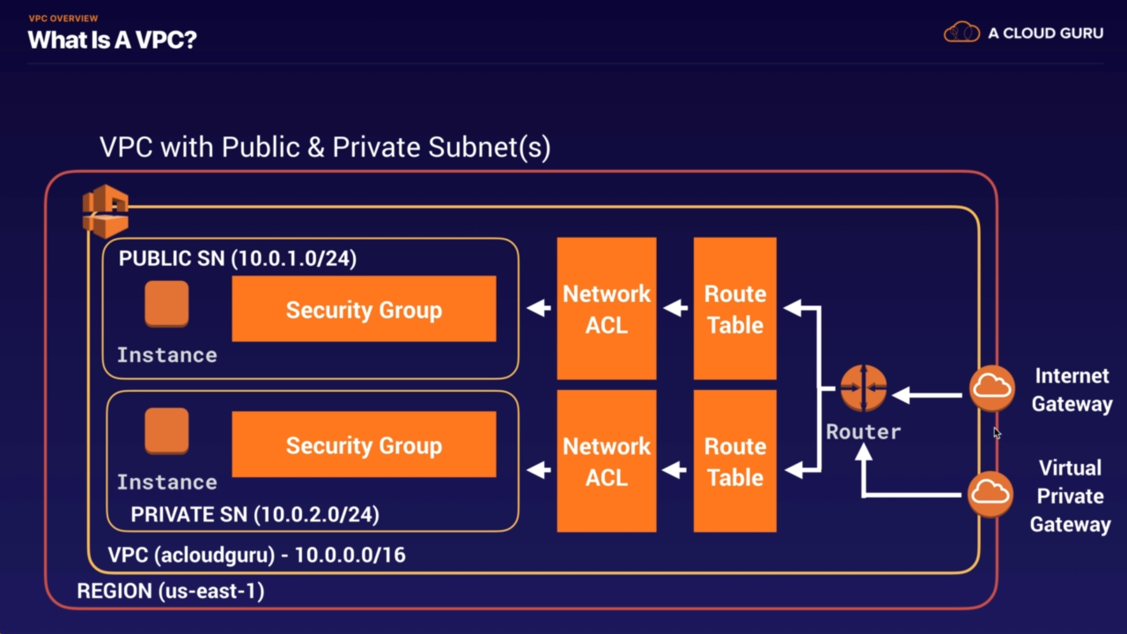

Subnet are classified as

**Public Subnet:** Public subnet has access to Internet and hence Internet Gateway (IGW) need to be attached to VPC and the routing tables needs to be updated of the public subnet.

**Private Subnet:** Does not have access to Internet

**Bastion hosts/Jumper server**: Instances in public subnet which can be used to access instances of private subnet using SSH/RDP etc are called Bastion Host/Jump(er) server.

Note: **Security Group is Stateful and Network ACL is Stateless. i.e In NACL we will have to set both inbound and outbound rules separately hence Stateless while in Security Group we only need to set rule either in any one of the categories (inbound or outbound) and it automatically applies for other category too.**

Example VPC:

1. Since VPC are **region** based select a region i.e Oregon and give it a name (test VPC) and IP
2. Now choose a **availably zone** (AZ A) and create subnets i.e subnet A1,subnet B1 and assign IPs
3. Now add an Internet Gateway (test-IGW) to subnet A1 and update the routing table and hence it will become a public subnet
4. Subnet B1 will still be private as it is not connected to Internet.

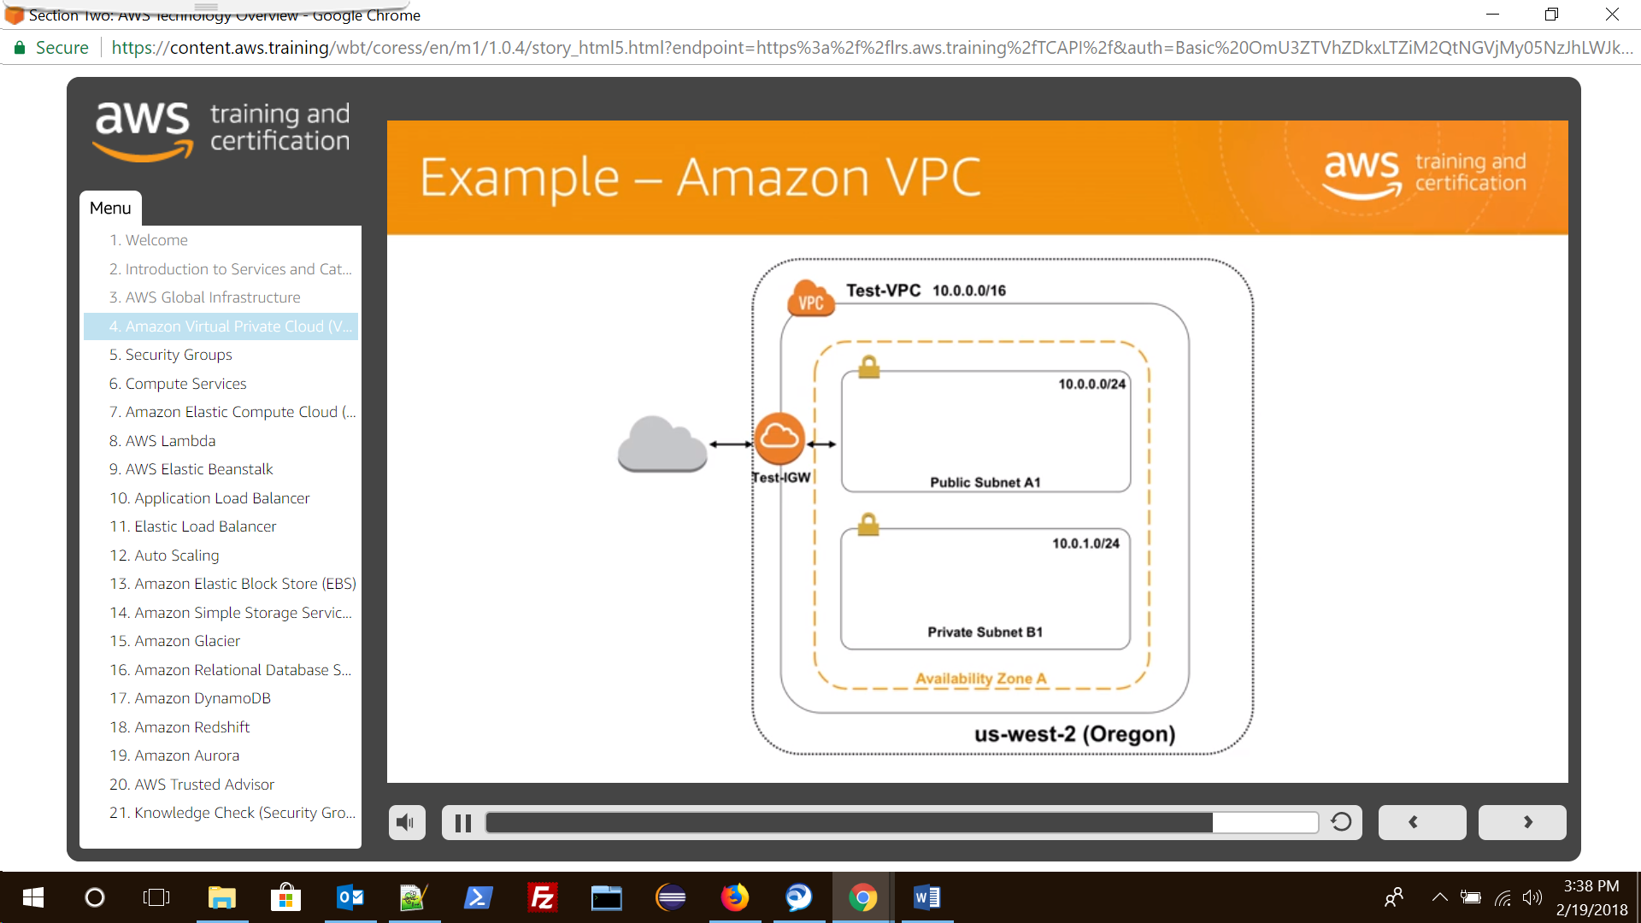

### VPC peering:

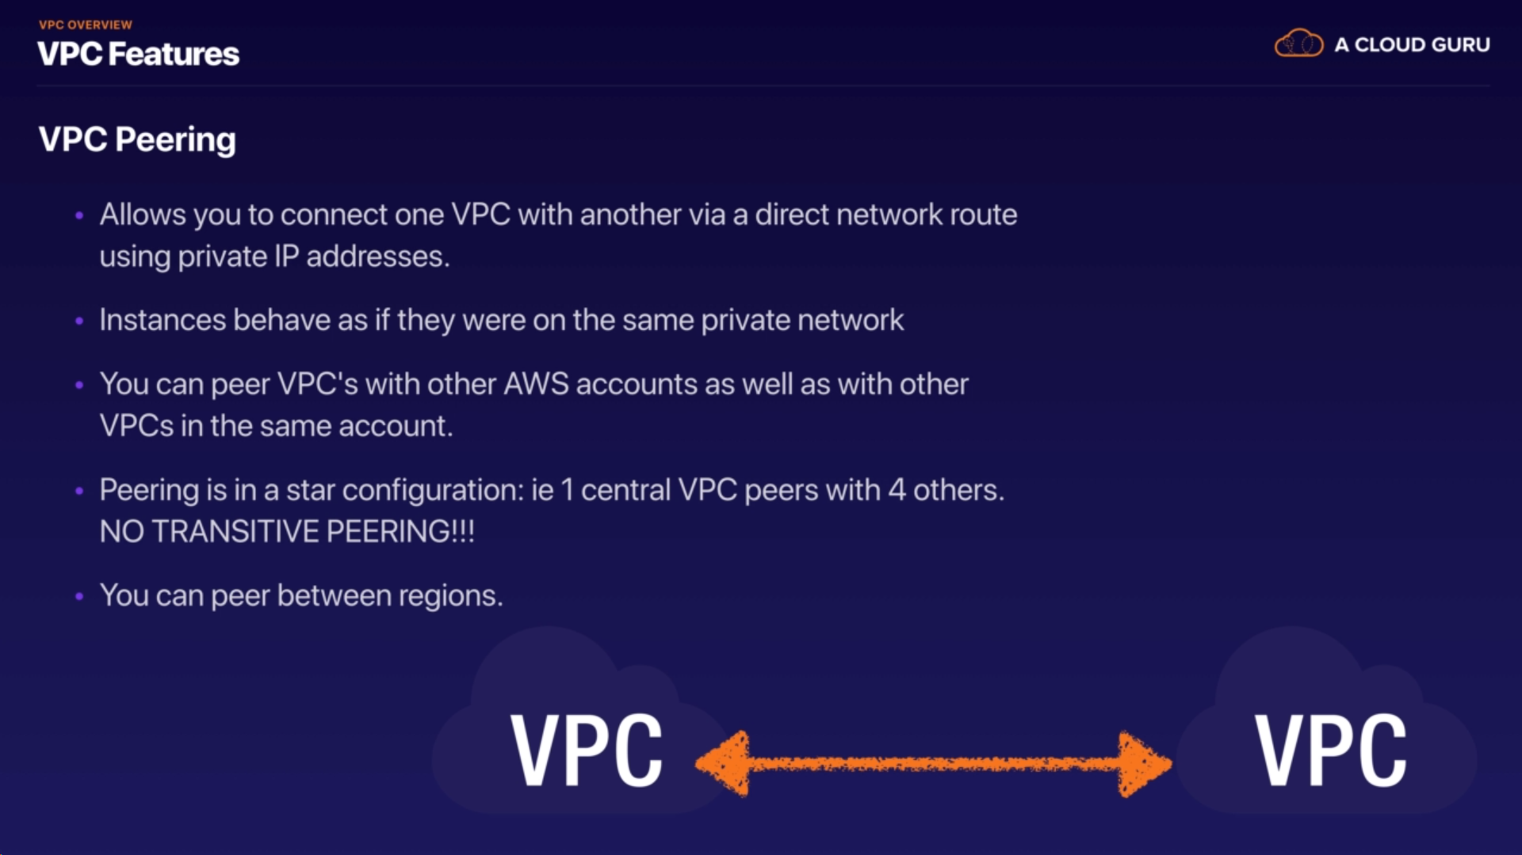

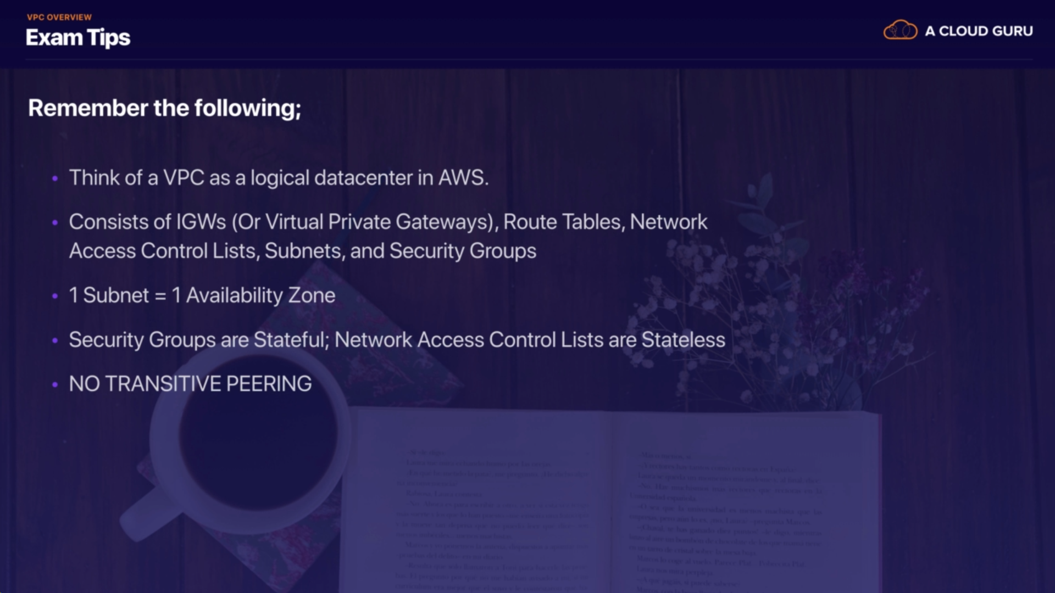

### Transitive Peering:

It means VPC B can only access systems of VPC A, while VPC A can access all the systems of VPC B, C, D, and E. VPC peering will have to be done between VPC B and VPC D in order for either of the VPC to access each other systems.

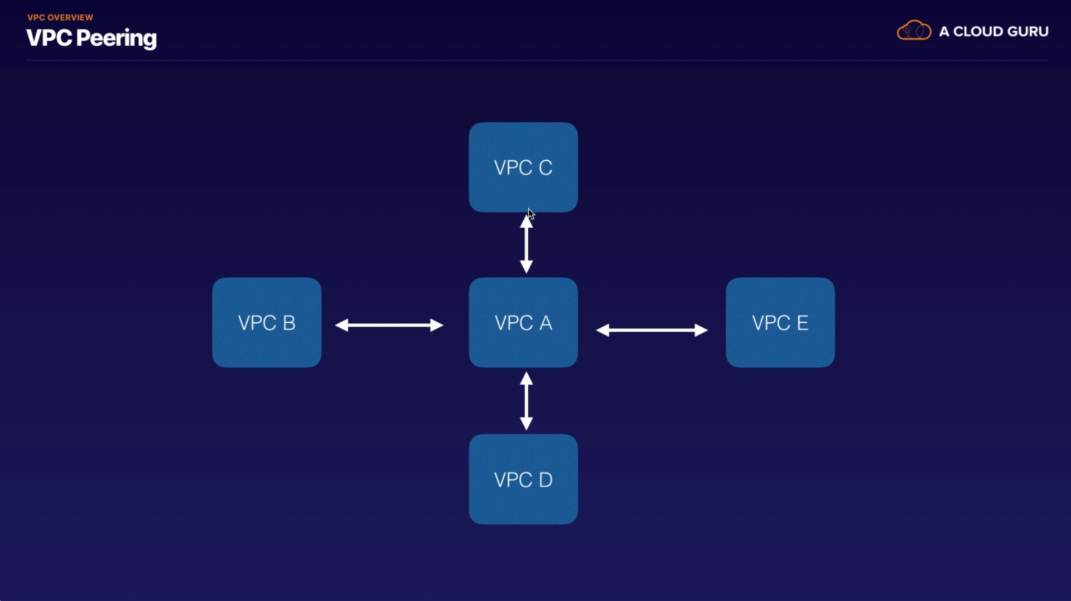

### Creating VPC

When we create a VPC using AWS console it cerates following components :

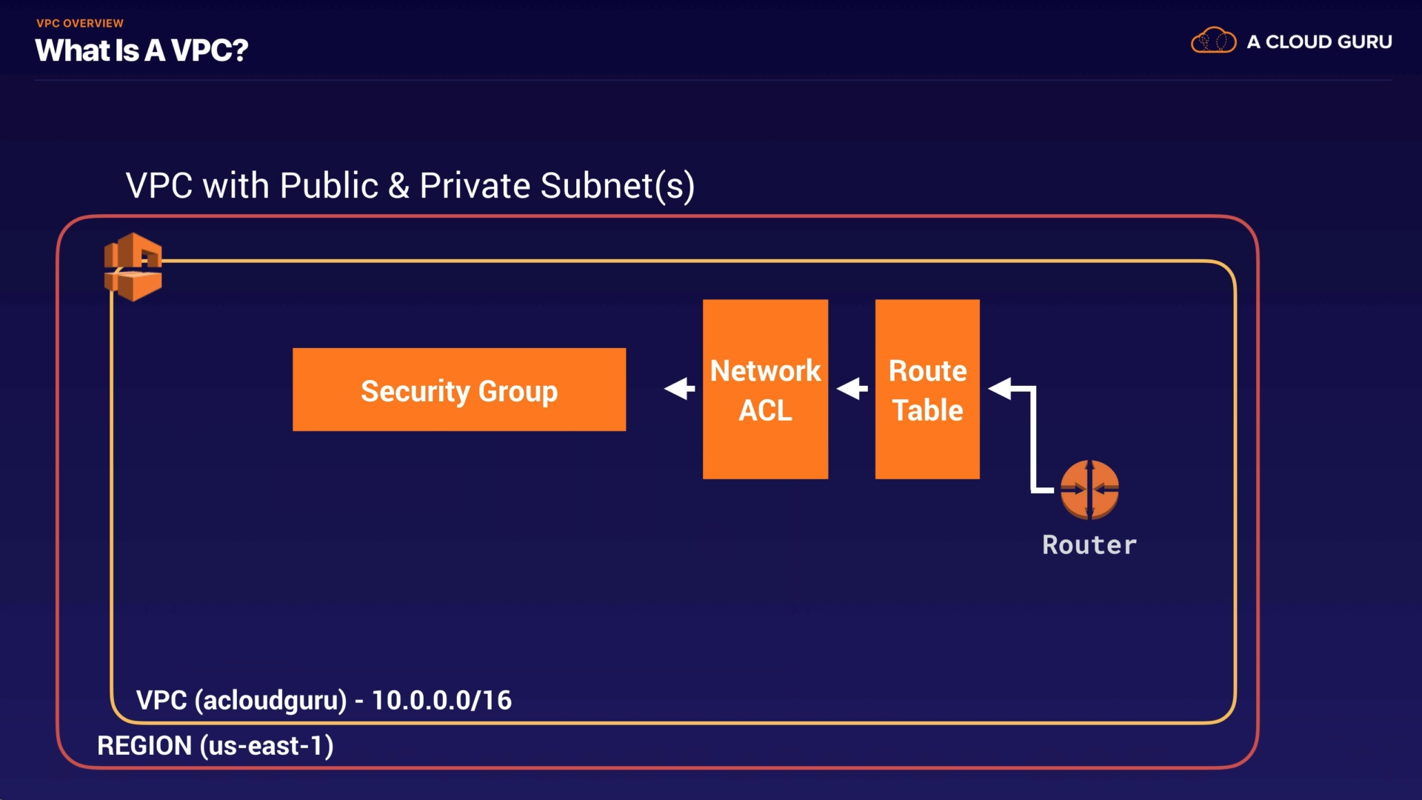

### NAT Instances and Gateway

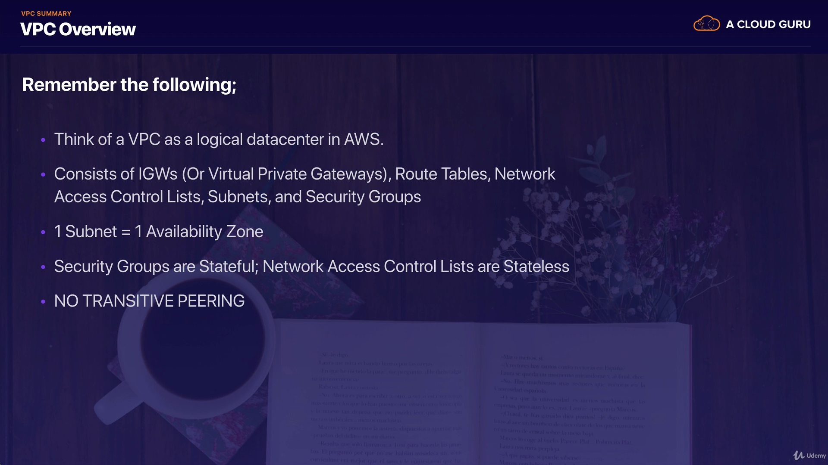

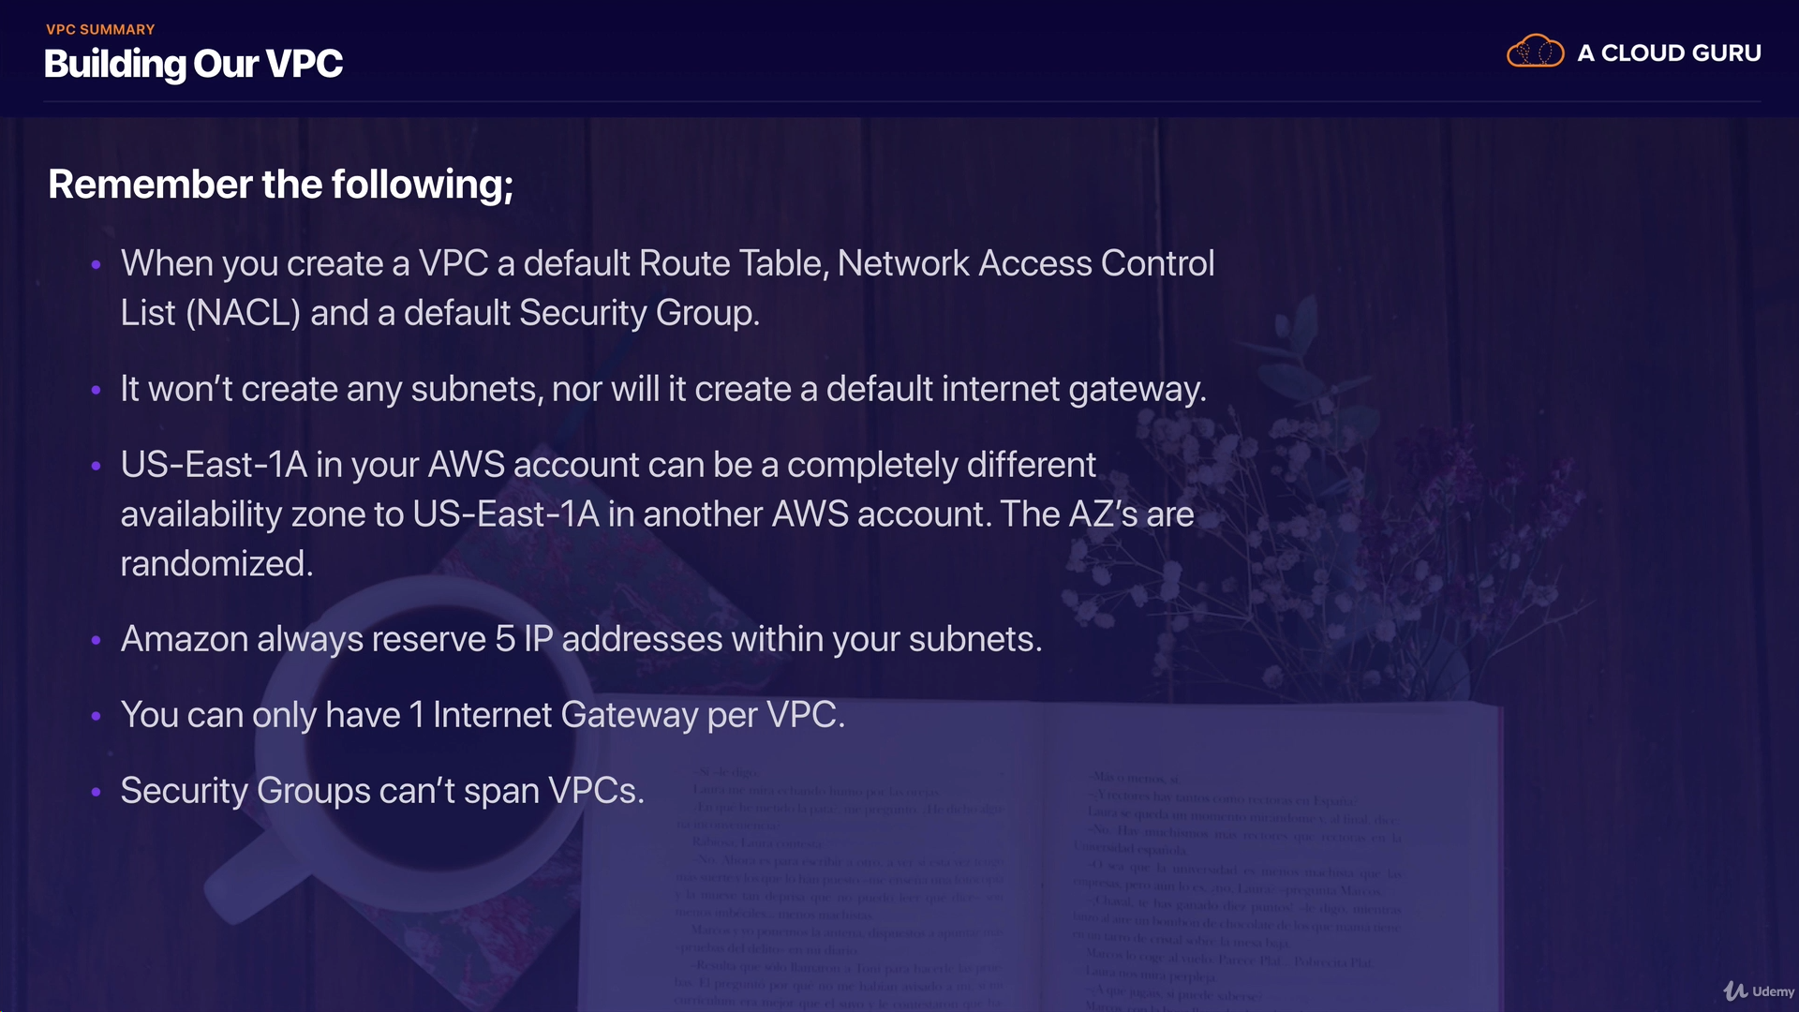

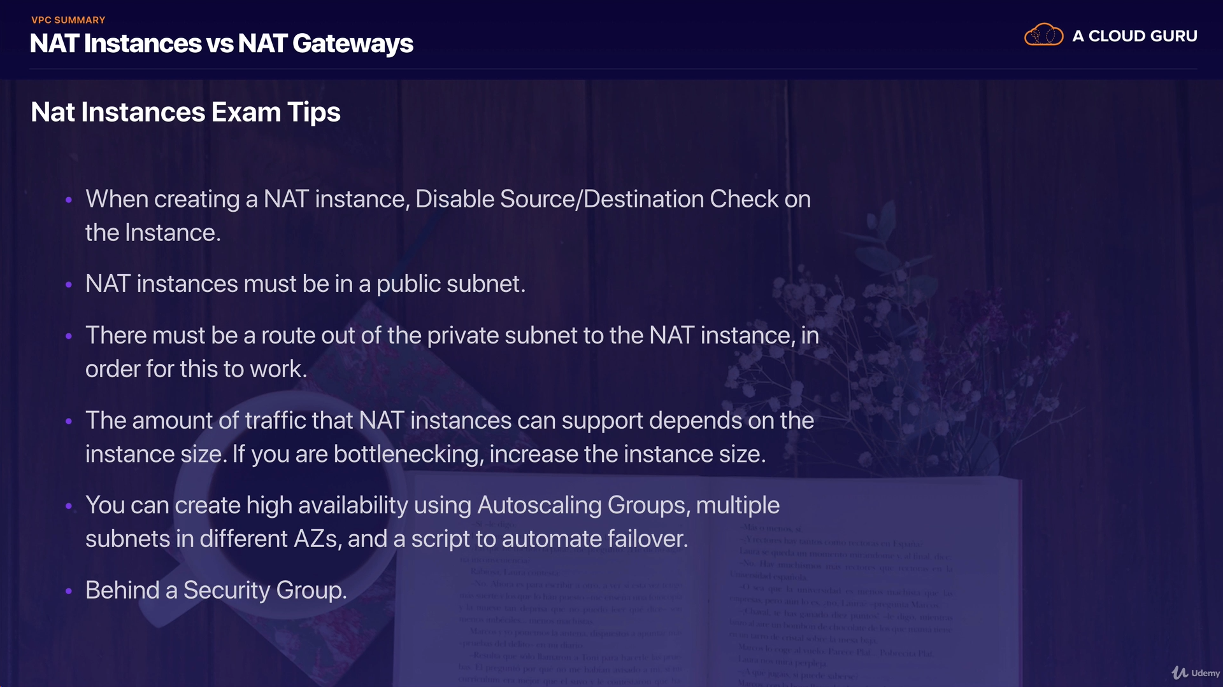

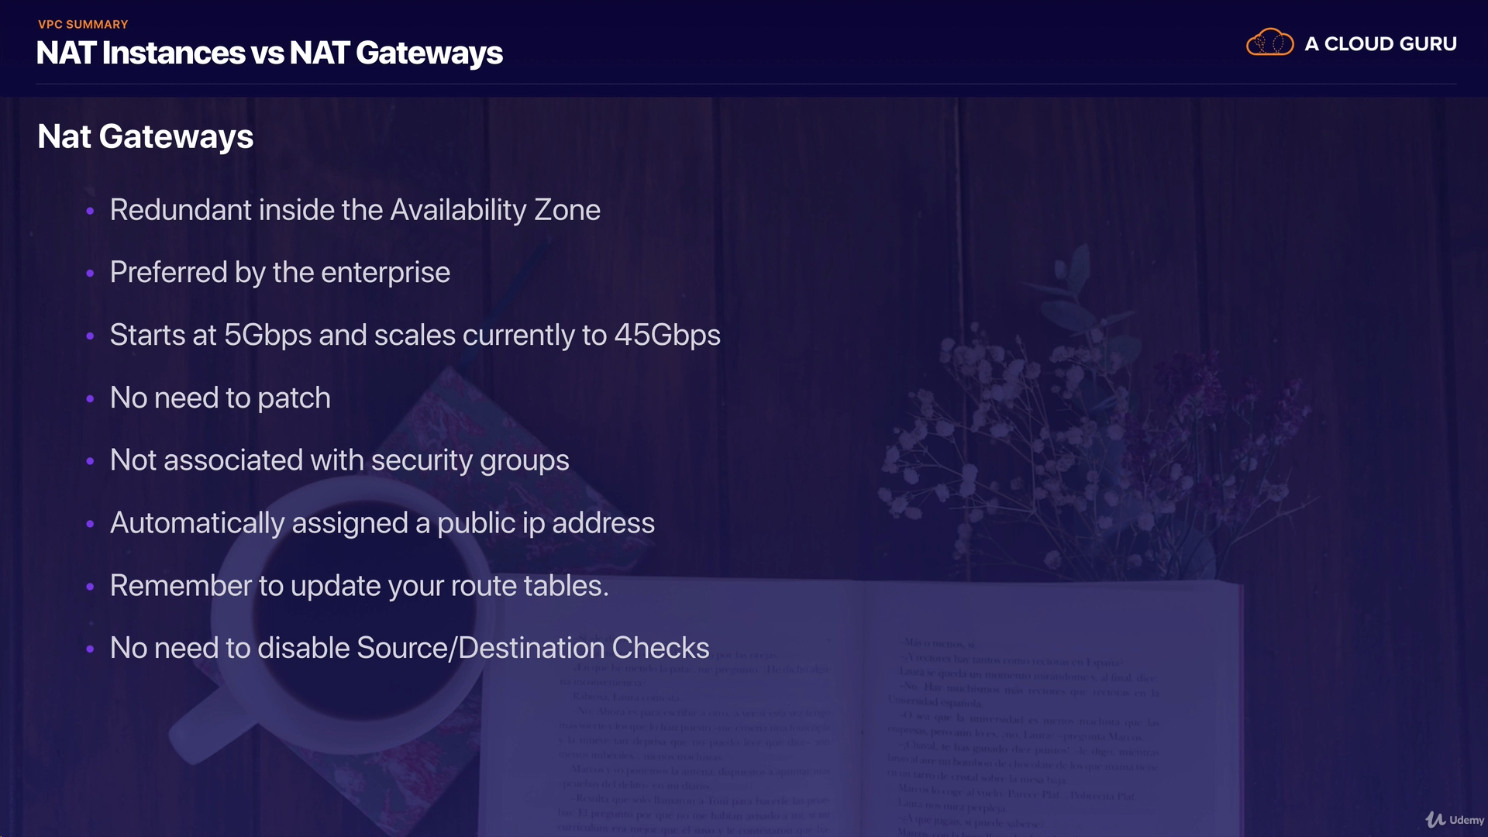

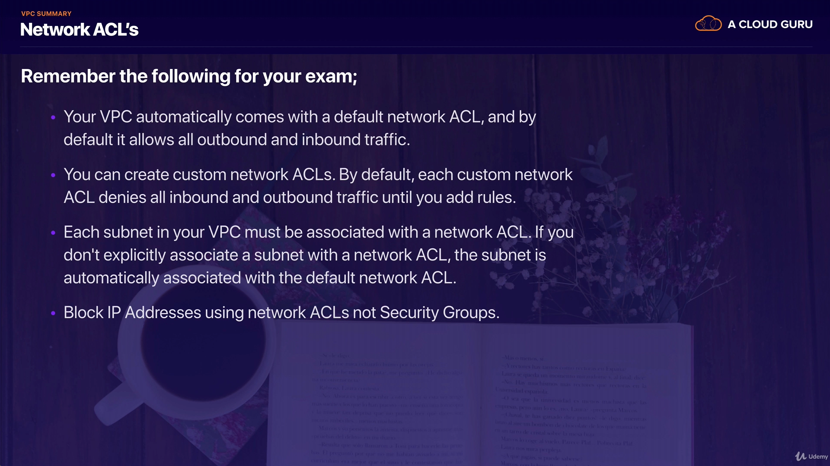

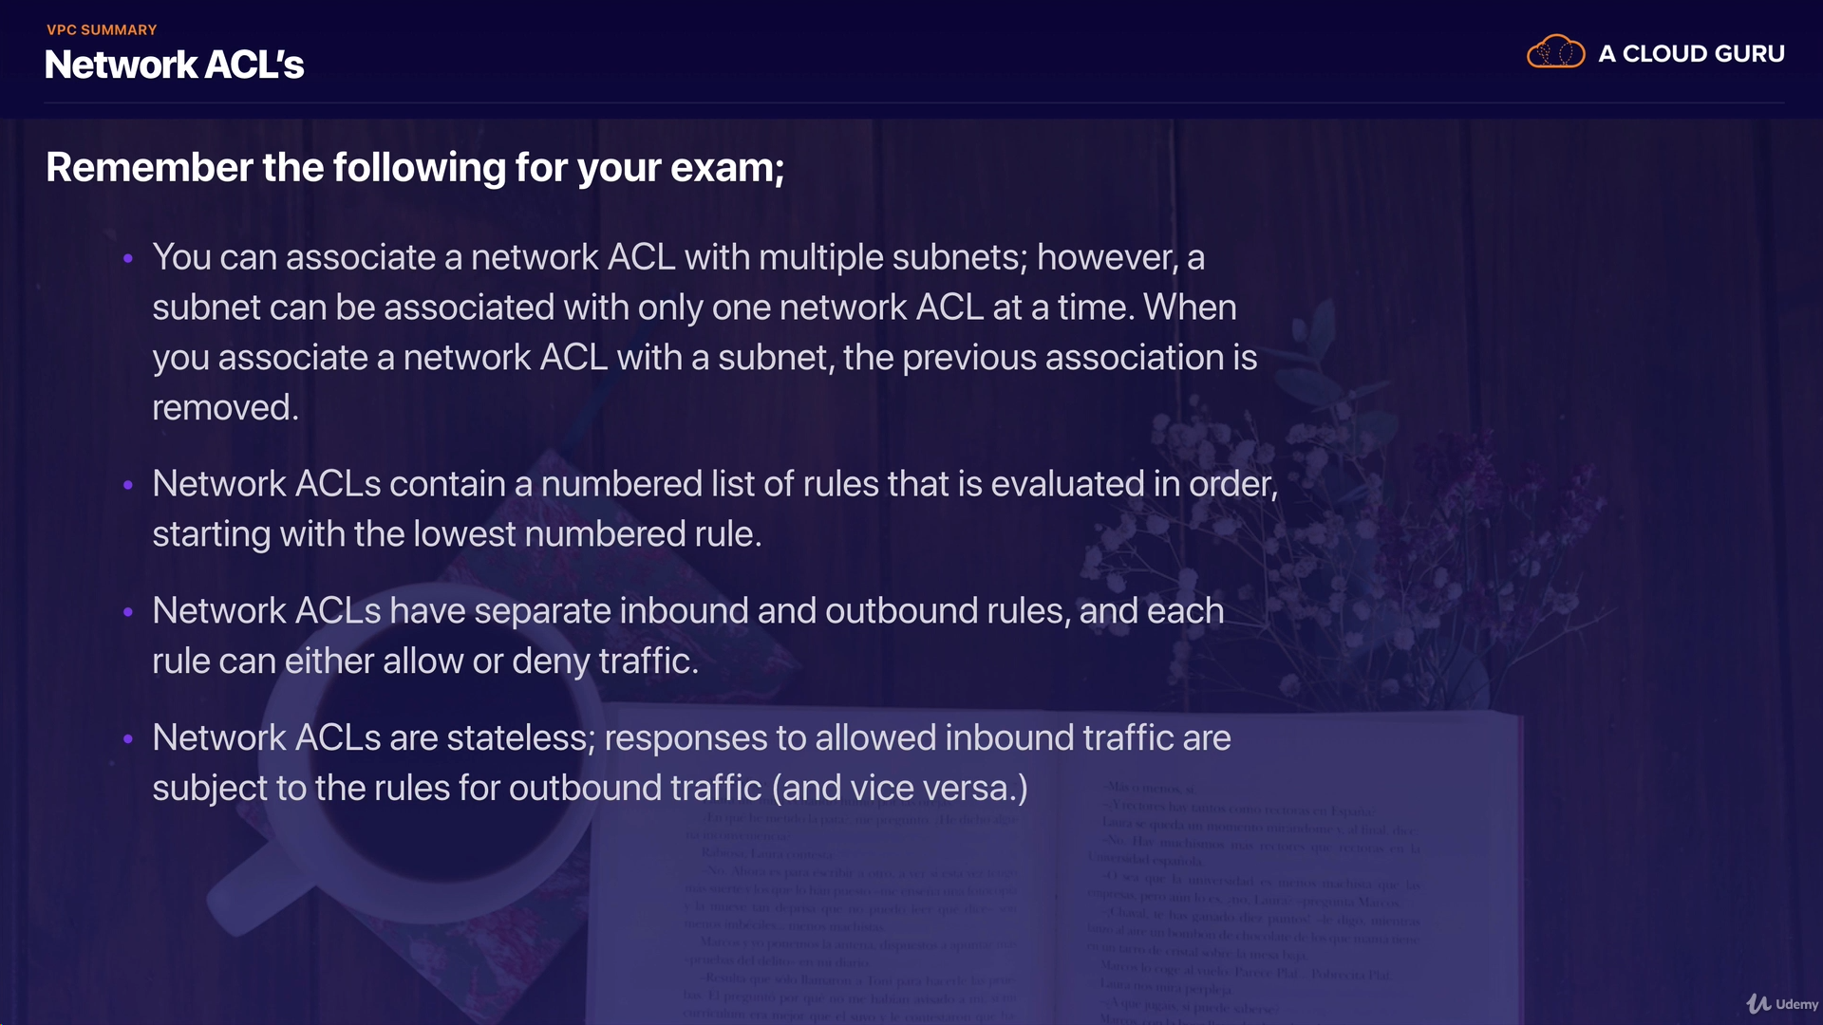

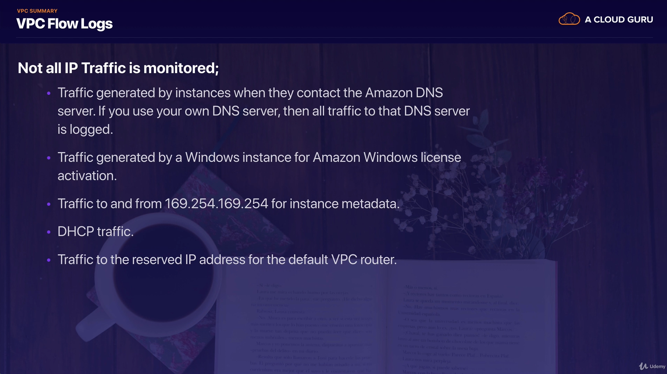

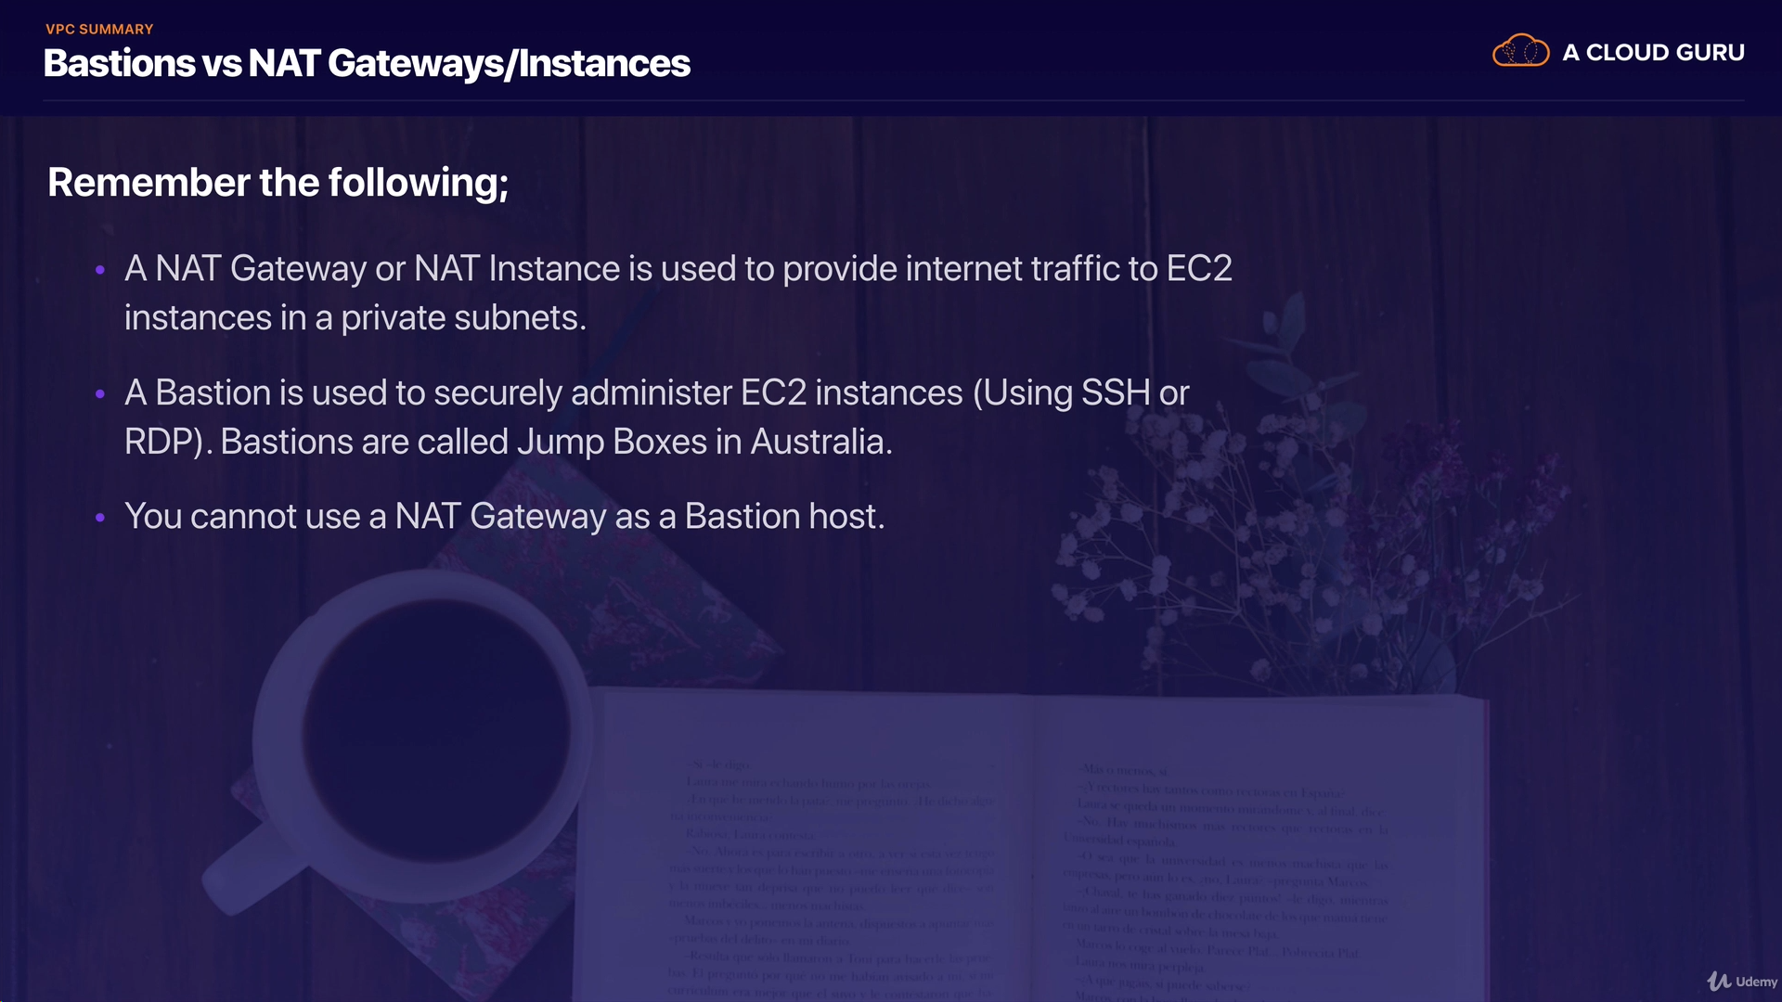

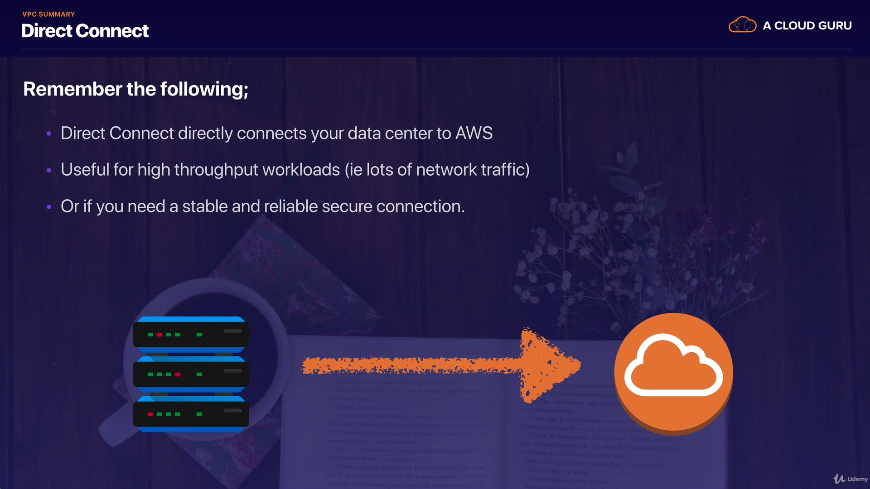

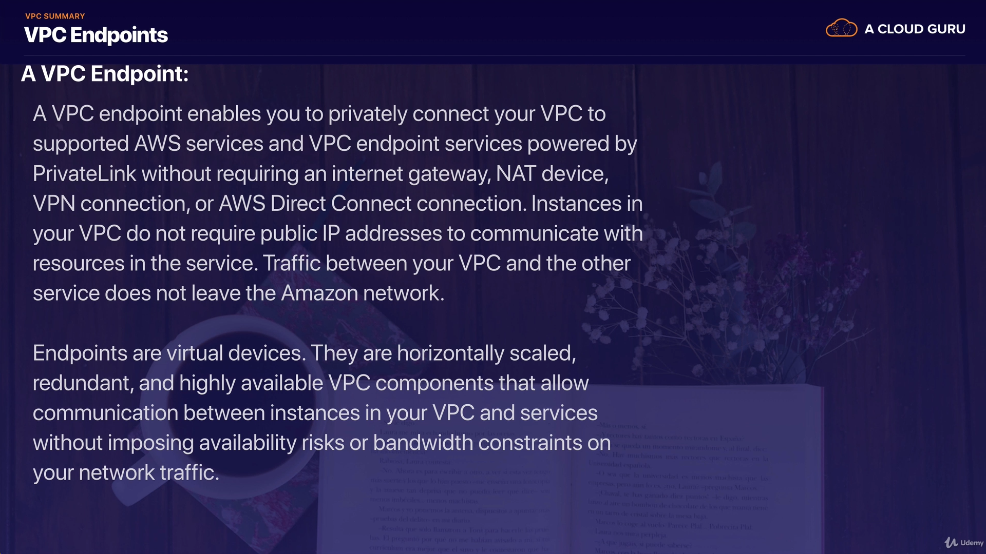

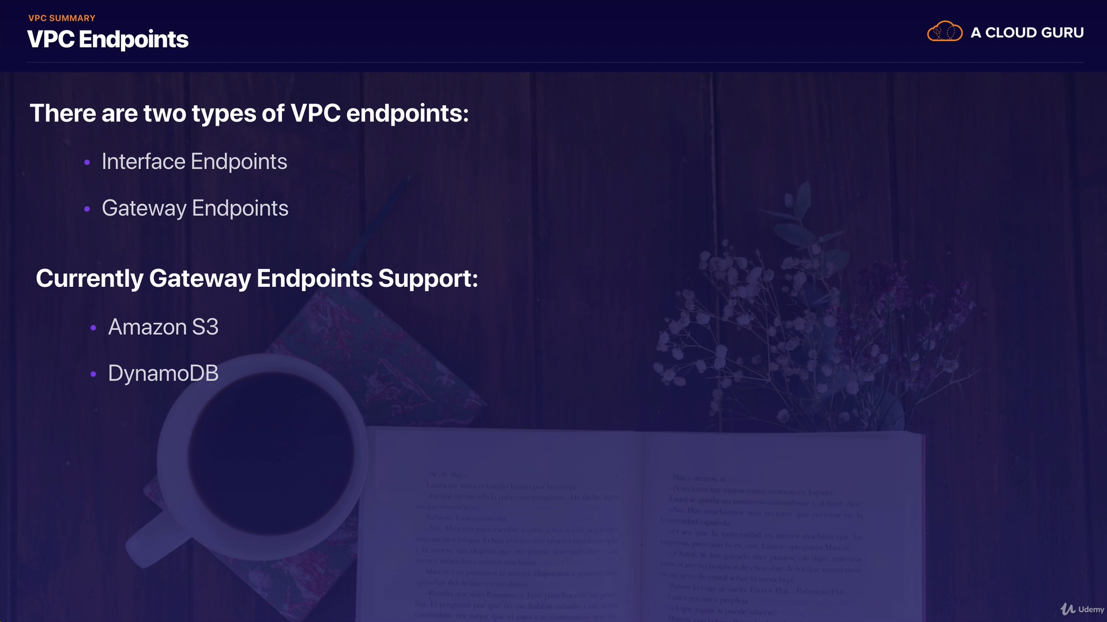

## 3.Security Groups

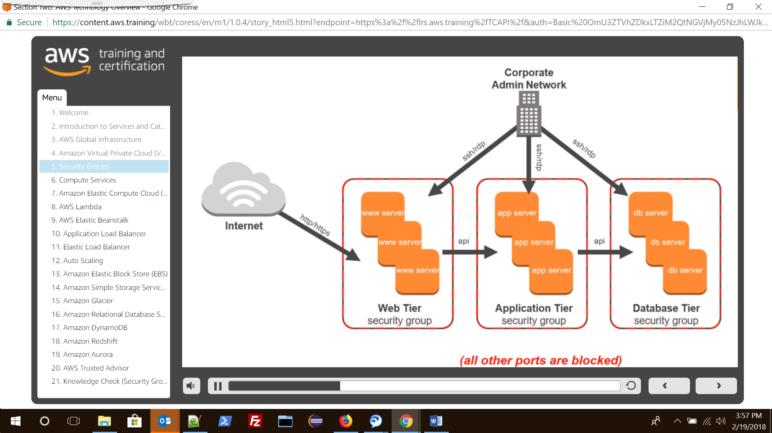

By default, all inbound traffic is denied and outbound traffic is allowed. Let’s enable inbound web traffic

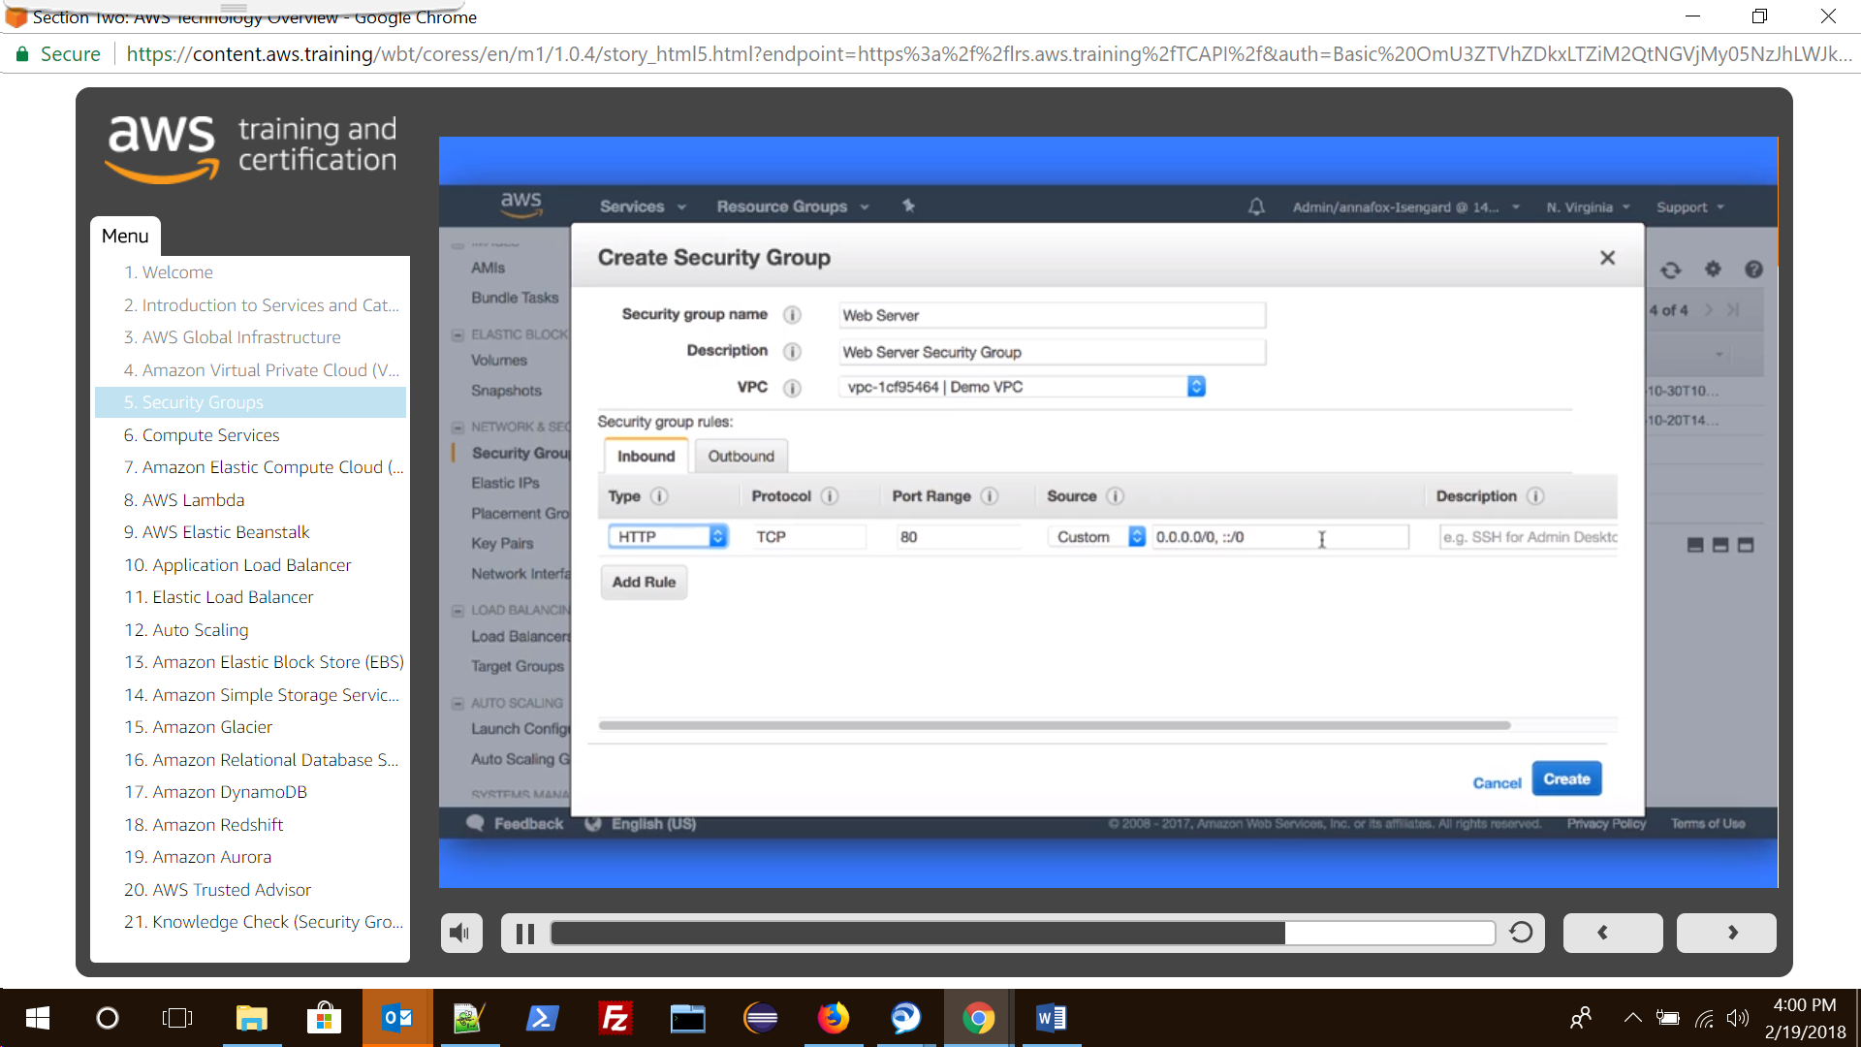

**Also note that even if we remove all the outbound traffic entries but have some lets say 8080 port enabled for inbound traffic then the same port will be open by default for outbound traffic as well. This is because two way communication for any inbound traffic can only happen if that port is also open in outbound traffic.**

Security Groups are ‘stateful’, ie if we only create inbound rules but do not have any outbound rules the two way traffic will still be allowed. Same is not true for ‘Network ACL’ which is ‘stateless’.

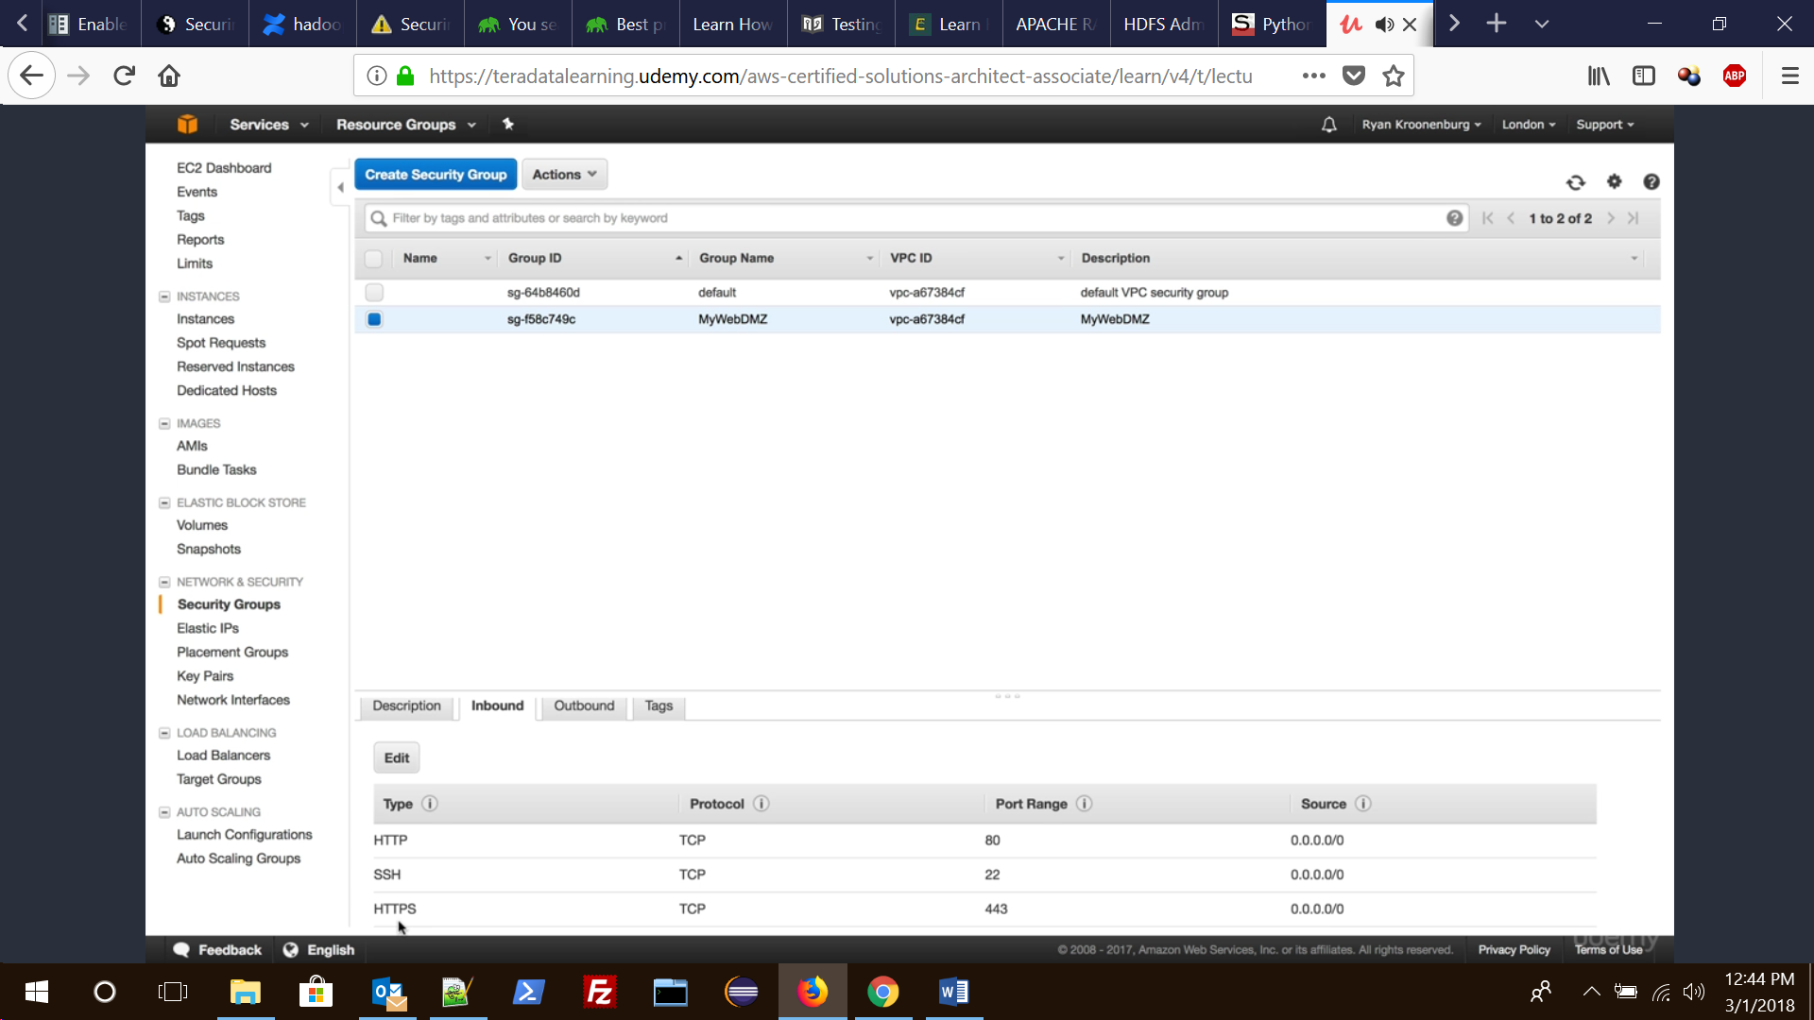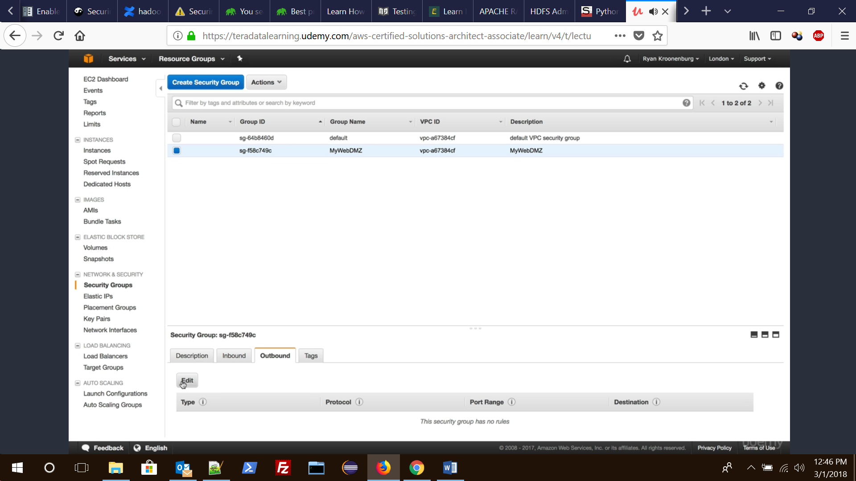

One can add more than one Security group to any service ie EC2. Also note that the changes to Security group gets reflected almost immediately.

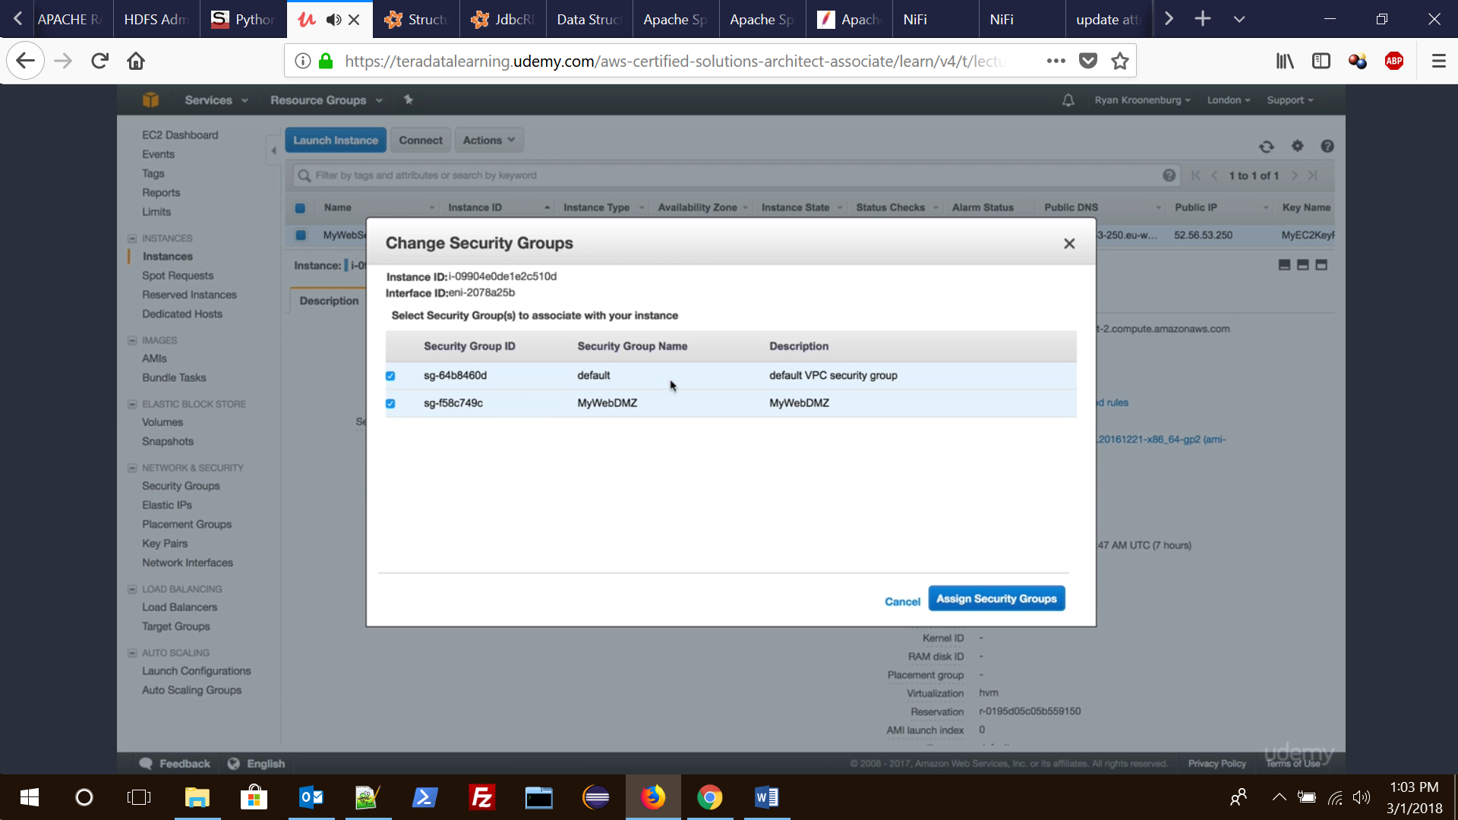

You cannot deny traffic to specific protocol, you can only enable ports for specific protocol.So its like you keep on adding protocols to security group, there is no such criteria or list that says deny traffic or block traffic for this protocol.

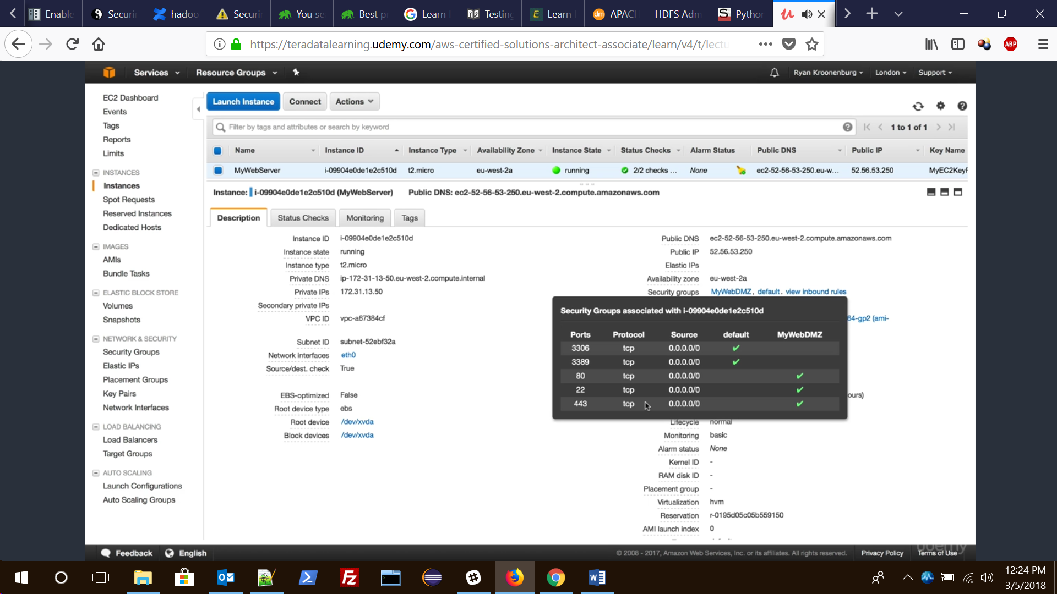

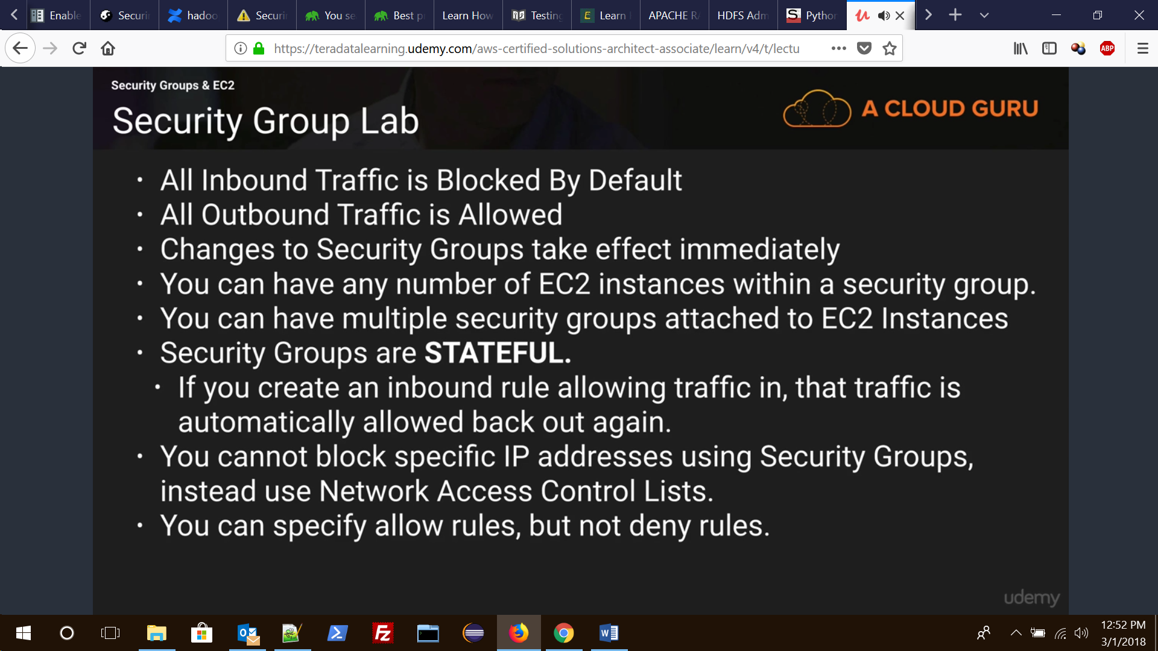

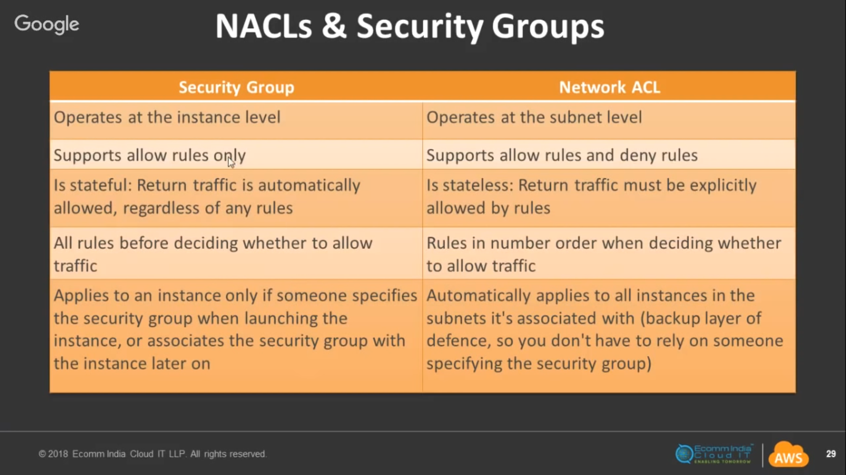

# AWS VPC Masterclass Webinar

<https://www.youtube.com/watch?v=LX5lHYGFcnA>

<https://www.youtube.com/watch?v=Tff1mekxOJ4>